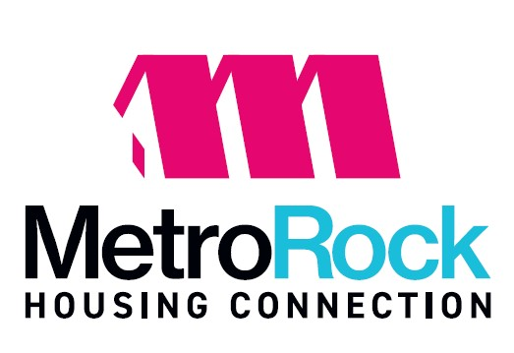

PUBLIC MEETING NOTICE
Board of Commissioners Meeting
May 21, 2026
Location: 621 17th Avenue, East Moline, IL. 61244
Time: 5:30 p.m.

AGENDA

- Roll Call
- Public Comments
- Call to Order – John Welling, Chair Pro Tempore
- Approval of the minutes of the April 2026 Regular Meeting motion
- Bills and Communications – Review of Accounts Payable for April 2026 motion
- Monthly Finance Reports N/A
- CEO & Financial Report (Amy Clark)
  - Deputy Director Report (Sheryl Shank)
- Presentation of Bids / Proposals
- Committee Reports N/A
- Unfinished Business N/A
- New Business N/A
  - Resolution # 1262: Approve SEMAP Certification for FYE 3/31/2026 motion
  - Resolution # 1263: Approve Corporate Account Access
- Executive Session to Discuss Personnel, Litigation and Real Estate Transactions per 5 ILCS 120/2 (c)(1), (c)(11), (c)(5)(6)
- Any other business that may come before the Board
- Meeting Adjournment motion

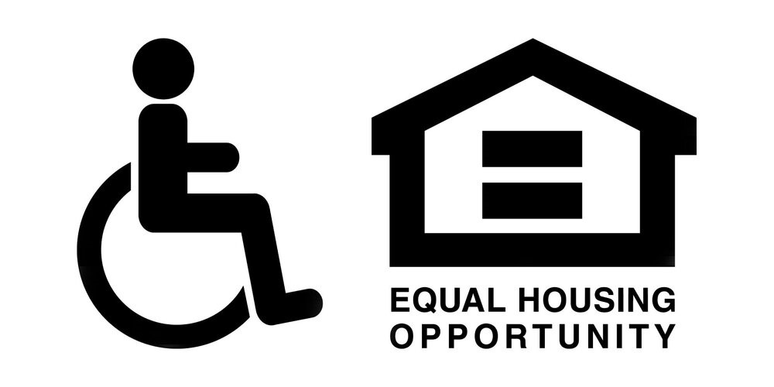

Mission Statement
Working together to provide and maintain quality housing
that is safe, secure and affordable.

President & CEO

Amy S. Clark

BOARD OF COMMISIONERS

Rebecca McReynolds
Interim Chairman

John Welling
Interim Vice-Chair

Audrey Porter

Katie King

621 17th Avenue
East Moline, IL 61244
309.755.4527
MetroRockQC.org

