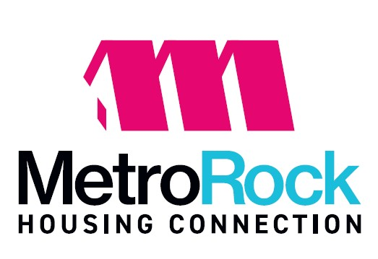
Notice of Changes to Public Housing Flat Rent Schedule Effective: January 01, 2027

Flat Rent Schedule

Bedroom Size | 2027 FMR | Current | Proposed
1-BR  2-BR | 852  1056 | 690  870 | 690  870
3-BR | 1396 | 1130 | 1130
4-BR | 1697 | 1390 | 1390
5-BR | 1951 | 1590 | 1590

The Department of Housing and Urban Development (HUD) has posted the Fair Market Rents (FMRs) for the fiscal year 10/01/2026 through 09/30/2027 FMR’s are used in the calculation of flat rents for Public Housing units. PHAs are required to establish flat rents at no less than 80 percent of the FMR for their jurisdiction.

FMRs are developed to include rent plus the cost of all necessary utilities. In the case where the PHA tenant family is responsible for making direct utility payments to the utility company, as is the case with GMAHA, dba MetroRock Housing Connection, housing units at Oak Grove, the flat rent is adjusted by the utility allowance per the most recently approved Utility Allowance Schedule.

At the admissions, families choose between the flat rent and the income –based rent. During the annual re-examinations, PHAs must offer an annual rent option, where the family may choose to pay either the lower of the flat rent or the calculated income-based rent.

The table above represents the final FFY 2027 FMR rates, the current GMAHA, dba MetroRock Housing Connection, Public Housing Flat Rent Schedule and the proposed FFY 2027 GMAHA Public Housing Flat Rent Schedule (adjustment for utility payments have been made to the “Current and Proposed flat rents listed).

Written comments to the Public Housing Flat Rents may be submitted to the central office through the 30-day comment period ending October 02, 2026.

Persons with disabilities requiring assistance or alternative format, or wishing to make comments in alternative formats can contact our office at 309-755-4527, ext. 406 or TTY 1-800-545-1833 ext. 820

Amy S. Clark, CEO

Posting Date: September 03, 2026 – October 02, 2026

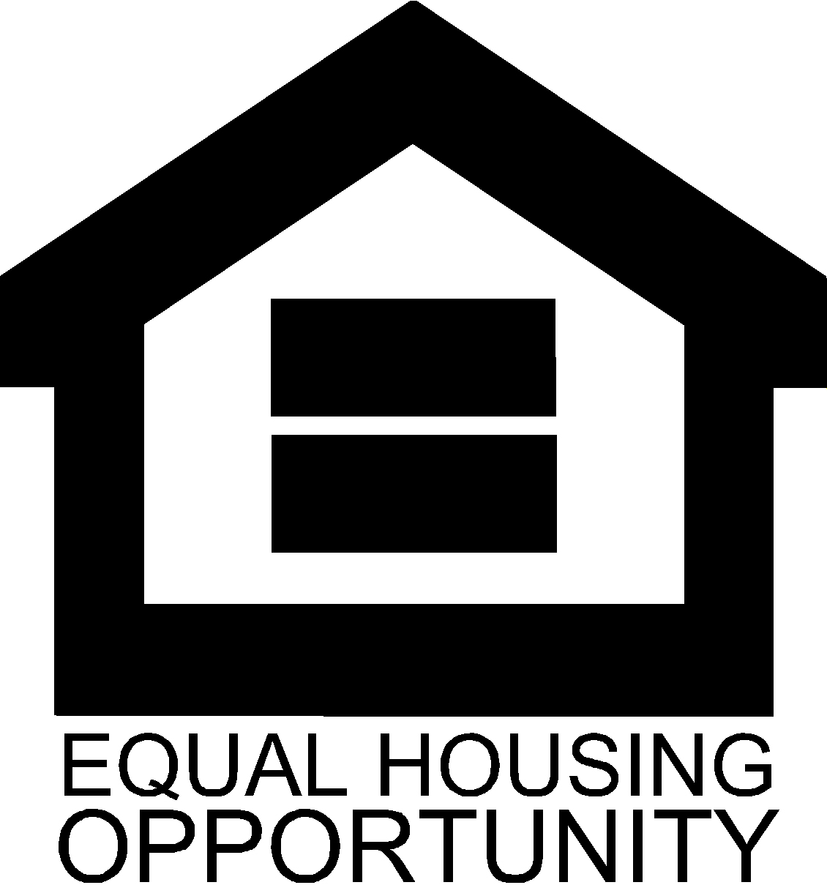

President & CEO

Amy S. Clark

621 17th Avenue
East Moline, IL 61244
309.755.4527
MetroRockQC.org

