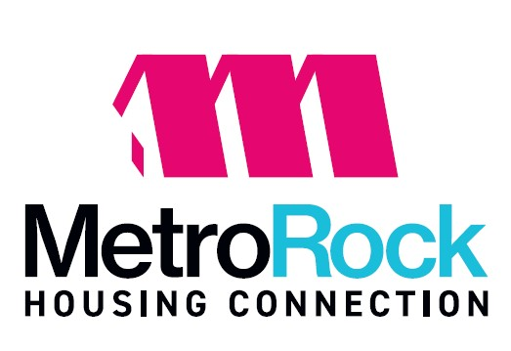

Notice of Changes to HCV Payment Standards
Effective: January 01, 2027

Payment Standard Schedule
BR Size / Current / Proposed

0-BR $ 898 $ 865
1-BR $ 1020 $ 937
2-BR $ 1257 $ 1161
3-BR $ 1647 $ 1535
4-BR $ 2000 $ 1866
5-BR $ 2300 $ 2146

The Housing Authority has completed its annual review of payment standards for the Section 8 HCV Program. Payment standards are used to calculate the housing assistance payment (HAP) the Greater Metropolitan Area Housing Authority of Rock Island County (GMAHA) pays to the landlords/owners on behalf of the participant leasing the unit. The range of payment standard amounts are based on HUD’s published fair market rent (FMR) in which the agency has jurisdiction.

Historically, GMAHA has established its payments standard schedule at maximum range of 110% of the FMR. Providing our funding level can support this range, this maximum range allows our clients current housing participants to remain in place when rents increase, a higher level of housing opportunity in higher income census tracts when they choose to move, and quicker lease-up for new families coming on the program.

In an effort to keep currently housed participants in place and not limit the availability of rental housing for our clients, the payment standards are requested to be at range of 110% of the FMR.

Written comments in regard to the proposed changes to HCV payment Standards may be submitted to the central office through the 30-day comment period ending October 02, 2026.

Persons with disabilities requiring assistance or alternative format, or wishing to make comments in alternative formats, can contact our office at 309-755-4527, ext. 406 or TTY 1-800-545-1833 ext. 820.

Amy S. Clark, CEO

Posting Date: September 03, 2026 – October 02, 2026


President & CEO

Amy S. Clark

621 17th Avenue
East Moline, IL 61244
309.755.4527
MetroRockQC.org

